How you find us

Arriving by car from the direction of Frankfurt
Take the motorway (Autobahn) A3 at Frankfurt to Würzburg via Aschaffenburg.
Leave the A3 at the exit "Würzburg-Heidingsfeld" (ca. 100 KM after Frankfurt).
Take a right turn to federal highway B19 , direction to Bad Mergentheim.
After ca. 35 KM turn left to the Romantic Road direction Rothenburg and Markelsheim (don't turn right to Bad Mergentheim).
After ca. 2 KM you will see Markelsheim on the right hand side.
When you arrive in Markelsheim, you can see our house when you turn right at the first crossroad.

Arriving by car from the direction of Stuttgart
Take the motorway (Autobahn) A81 at Stuttgart to Würzburg.
Leave the A81 at the exit "Boxberg" (ca. 90 KM after Stuttgart).
After you have left the motorway turn right, direction to Bad Mergentheim.
After 20 KM you will arrive in Bad Mergentheim.
Leave Bad Mergentheim, direction to Weikersheim and Rothenburg via Igersheim (Romantic Road).
6 KM after Bad Mergentheim you will see Markelsheim on the right hand side.
When you arrive in Markelsheim, you can see our house when you turn right at the first crossroad.

Arriving by car from the direction of Nuremberg
Take the motorway (Autobahn) A6 at Nuremberg, direction to Heilbronn.
Leave the A6 at the exit "Crailsheim" (ca. 80 KM after Nuremberg).
Take a right turn to federal highway B290 , direction to Bad Mergentheim.
After ca. 35 KM you will reach "Herbsthausen".
At the first crossroad in Herbsthausen turn right, direction to Markelsheim via Apfelbach.

Map of our location
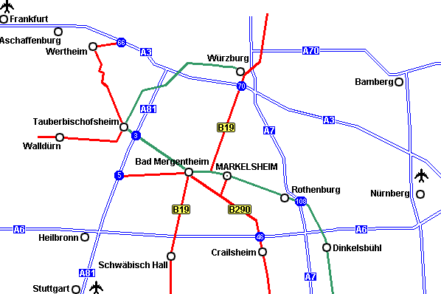

Arriving by Bicycle

Regardless of which direction our house is very easy to be found. Leave the bicycle lane in Markelsheim at the Tauber bridge. Our house is situated on the left-hand side in about 80 meters.

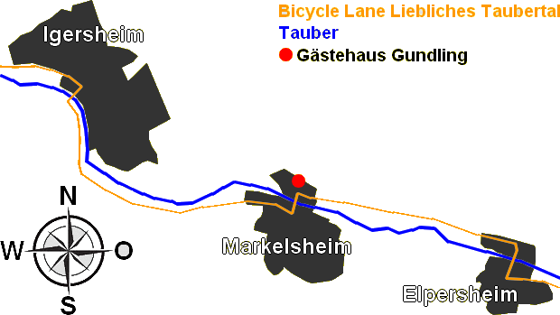

Arriving by train

A railway station of the Deutsche Bahn is situated in Markelsheim. From there, you can reach Bad Mergentheim and Weikersheim in the space of 6 minutes. Moreover, there are direct connections to Aschaffenburg, Miltenberg, Wertheim, Tauberbischofsheim, Lauda and Crailsheim.



